Face Detection Using Skin Segmentation
Analysis using various Color-Models

Rishi Raj Singh Jhelumi , Prachish Gora
Department Of Computer Science and Engineering
International Institute of Information Technology
Hyderabad – 500032, India
Email: rishirajsingh.jhelumi@students.iiit.ac.in
prachish.gora@students.iiit.ac.in

Abstract— Human face detection has become a major field of interest in current research because there is no deterministic algorithm to find face(s) in a given image. Further the algorithms that exist are very much specific to the kind of images they would take as input and detect faces. The problem is to detect faces in the given, colored group photograph. In this paper, an improved segmentation algorithm for face detection in color images with multiple faces and skin tone regions is proposed. Algorithm ingeniously uses various skin color models, RGB, HSV, YCbCr and their combinations for the detection of human faces. Skin regions are extracted using a set of bounding rules based on the skin color distribution obtained from a training set. The segmented face regions are further classified using a parallel combination of simple morphological operations. Experimental results on a large photo data set have demonstrated that the proposed model is able to achieve good detection success rates for near-frontal faces of varying orientations, skin color and background environment.
Keywords—Face detection; skin color; color models; skin classification; bounding box ; eccentricity;

Introduction
Detection of the human face is an essential step in computer vision and many biometric applications such as automatic face recognition, video surveillance, human-computer communication and large-scale face image retrieval systems. The first and foremost important step in any of these systems is the accurate detection of the presence and the position of the human faces in an images or video. The main challenges encountered in face detection is to cope with a wide variety of variations in the human face such as posture and scale, face orientation, facial expression, ethnicity and skin color. External factors such as occlusion, complex backgrounds inconsistent illumination conditions and quality of the image may also contribute significantly to the overall problem. Color is known to be a useful clue to extract skin regions and it is only available in color images. This allows easy face localization of potential facial regions without any consideration of its texture and geometrical properties. Most techniques up to date are pixel-based skin detection methods, which classify each pixel as skin or “non-skin” individually and independently from its neighbors. Some of the early methods used various statistical color models such as a single Gaussian model, Gaussian mixture density model and histogram based model.

Various colors spaces provide us various discriminality between skin pixels and non-skin pixels over various illumination conditions. Skin color models that operate only on chrominance subspaces such as the YCbCr and HSV have been found to be effective in characterizing various human skin colors.

In this paper, we present various skin color models RGB, HSV, YCbCr for human face detection. This model utilizes the additional hue and chrominance information of the image on top of standard RGB properties to improve the discriminality between skin pixels and non-skin pixels. In our approach, skin regions are classified using the RGB boundary rules and also additional new rules for the HSV and YCbCr subspaces. These rules are constructed based on the skin color distribution obtained from the training images. The classification of the extracted regions is further refined using a parallel combination of morphological operations.

Overview of Algorithm

RGB-HSV-YCbCr
Skin models
Histogram
Equalization

Skin Region Segmentation

Morphological
Operations

Region Labeling

Fig: 1 Algorithmic view of Face Detection System

Fig: 1 show the system overview of the proposed face detection system, which consists of a training stage and detection stage. Three commonly known color spaces RGB, HSV and YCbCr are used to construct the proposed hybrid model. Bounding planes or rules for each skin color subspace are constructed from their respective skin color distributions.
In the first step of the detection stage, we applied the histogram equalization to increase the contrast while keeping brightness unchanged. Then the bounding rules of the skin models are used to segment the skin regions of input test images. After that, combinations of morphological operations are applied to the extracted skin regions to eliminate possible non-face skin regions. Finally, the last step labels all the face regions in the image and returns them as detected faces. Our system is restricted to color images only.

The Skin Segmentation Model

Preparation of Color Models from Training Image set

In order to build the skin color model, a set of training images were used to analyze the properties and distribution of skin color in various color subspaces. Our training image set composed of 40 color images obtained from the Internet, covering a wide range of variations (different ethnicity and skin color). These images contained skin color regions that were either exposed to normal uniform illumination, daylight illumination (outdoors) or flashlight illumination (under dark conditions).

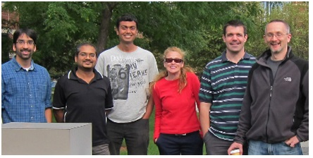
Original Image

Histogram Equalization
The first part of the model use histogram equalization to increase the contrast while keeping the brightness of the image constant. The Algorithm involved is Brightness Preserving Dynamic Fuzzy Histogram Equalization.
The Output of using the histogram equalization is shown below:
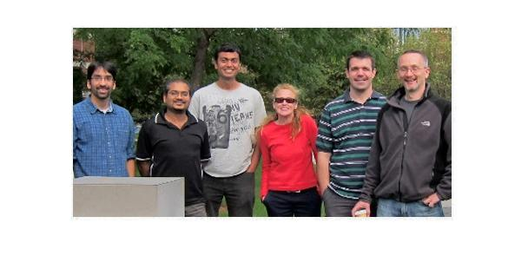
Image after Histogram Equalization

Skin Color Bounding Rules
The training images were analyzed in the RGB, HSV and YCbCr spaces. In RGB space, the skin color region is not well-distinguished in all 3 channels. A simple observation of its histogram will show that it is uniformly spread across spectrum of values.

Values Obtained from Training image set:

RGB :
V = [R,G,B];

(R > 50 && G > 40 && B > 20 && (max(v) - min(v) > 10 ) && (abs(R-G) >= 10) && R>G && R>B) || ((R>220) && (G>210) && (B>170) && (abs(R-G)<=15) && (R>B) && (G>B))

HSV :
(H > 0 && H < 35) || (H > 325 && H < 360)
S > 0.2 && S < 0.6
V >= 20

YCbCr :
Cb >= 60 && Cb <= 130
Cr >= 130 && Cr <= 165
Y >= 85

Skin Color Detection using Various Models:

- RGB
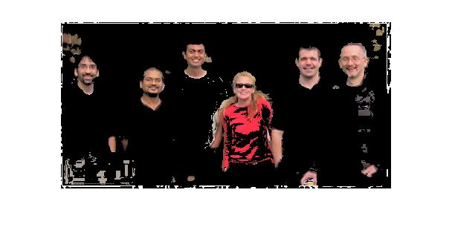
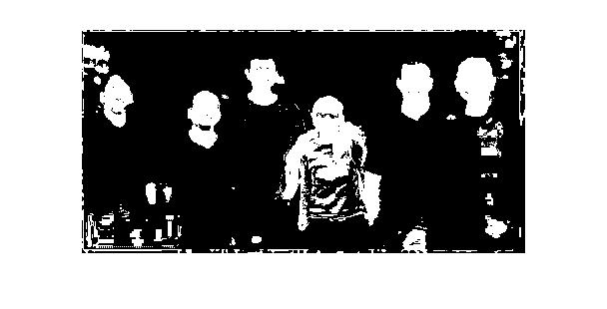

- HSV

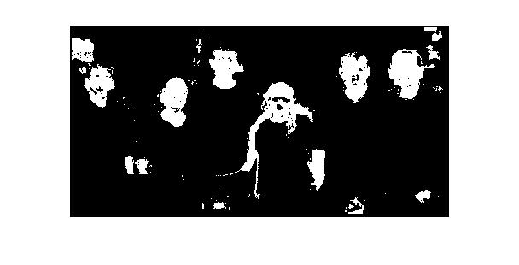
- YCbCr
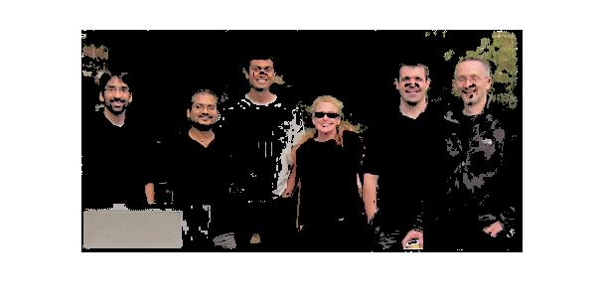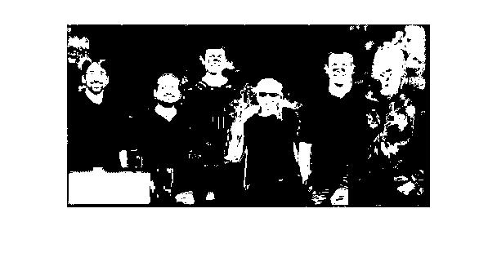

- RGB ∩ HSV

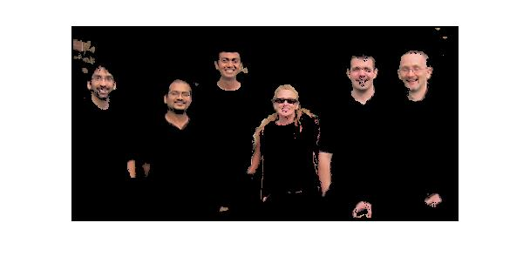
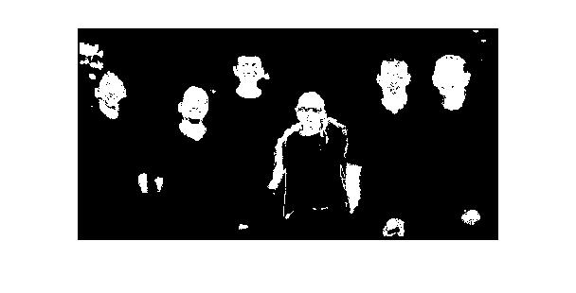
- RGB ∩ YCbCr
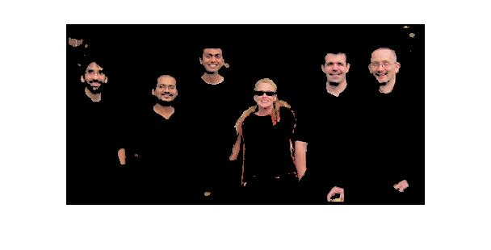
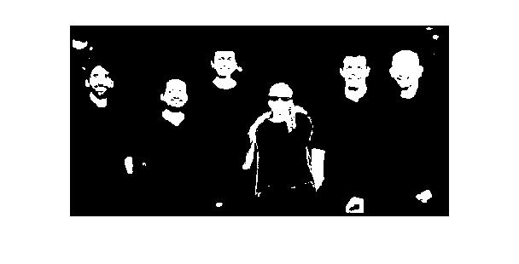

- HSV ∩ YCbCr
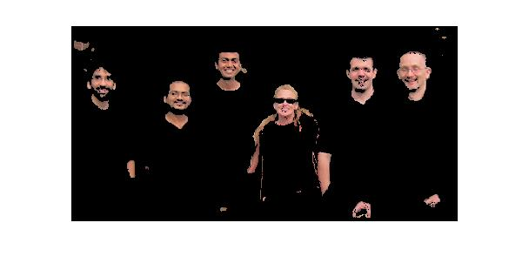
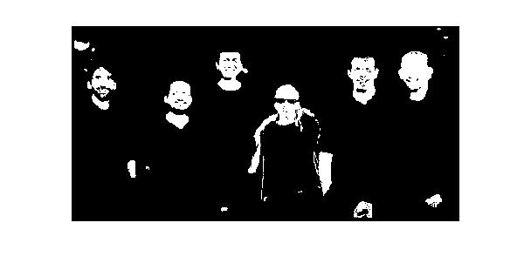
- RGB ∩ HSV ∩ YCbCr
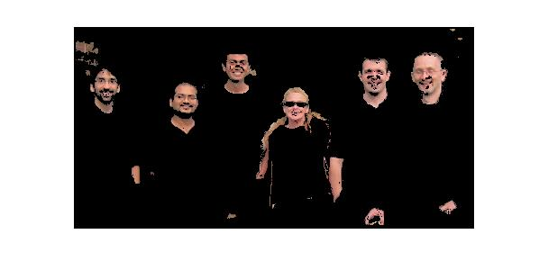
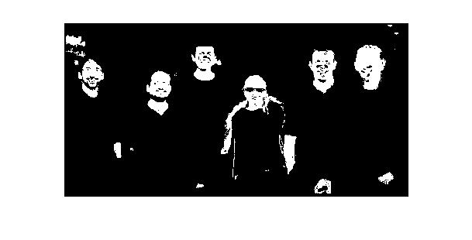

Skin Color Segmentation

The proposed combination of all 3 bounding rules from the RGB, HSV and YCbCr subspaces is named the “RGB-HSV-YCbCr” skin color model. Although skin color segmentation is normally considered to be a low-level or “first-hand” cue extraction, it is crucial that the skin regions are segmented precisely and accurately. Our segmentation technique, which uses all 3 color spaces, was designed to boost the face detection accuracy, as will be discussed in the experimental results.

The resulting segmented skin color regions have three
Common issues:
a) Regions are fragmented and often contain holes and gaps.
b) Occluded faces or multiple faces of close proximity may result in erroneous labeling
c) Extracted skin color regions may not necessarily be face regions. There are possibilities that certain skin regions may belong to exposed limbs (arms and legs) and also foreground and background objects that have a high degree of similarity to skin color.

Morphological Operations

The next step of the face detection system involves the use of morphological operations to refine the skin regions extracted from the segmentation step.

The first step that we include is a simple hole filling operation to fill any holes or gaps in the individual blobs. For opening the narrowly connected blobs we subtract the image obtained from bwperim function (MATLAB) from the main binary image for a specified number of times, thus finally separating the narrowly connected regions. As the subtraction leads to loss in size of the individual blobs our final morphological operation includes a dilate function to maintain a particular size of the skin detected individual blobs.

Additional measures are also introduced to determine the likelihood of a skin region being a face region. Two region properties – box ratio and eccentricity are used to examine and classify the shape of each skin region.

The box ratio property is simply defined as the width to height ratio of the region bounding box. By trial and error on the training set we have found that the good range of values lie between 1.2 and 0.4. Ratio values above 1.2 would not suggest a face since human faces are oriented vertically with a longer height than width. Meanwhile, ratio values below 0.4 are found to misclassify arms, legs or other elongated objects as faces.

The eccentricity property measures the ratio of the minor axis to major axis of a bounding ellipse. Eccentricity values of between 0.25 and 0.97 are estimated to be of good range for classifying face regions. Though this property works in a similar way as box ratio, it is more sensitive to the region shape and is able to consider various face rotations and poses.

- RGB
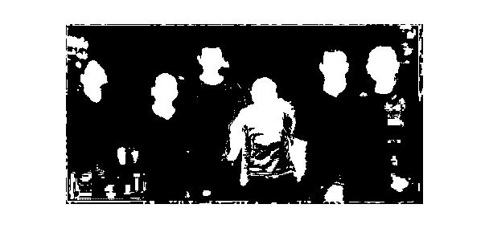
- HSV
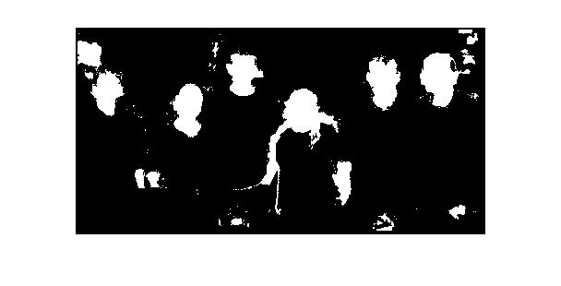
- YCbCr
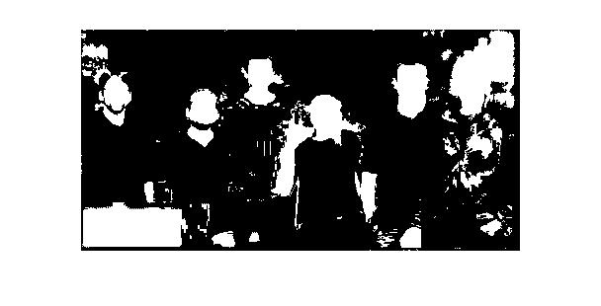
- RGB ∩ HSV
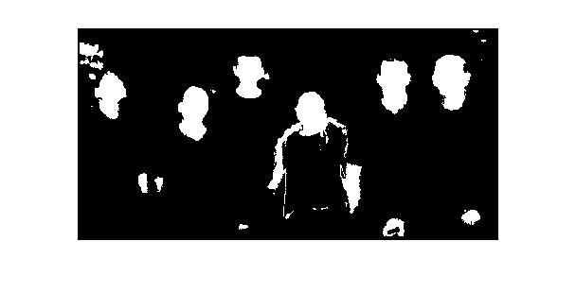

- RGB ∩ YCbCr
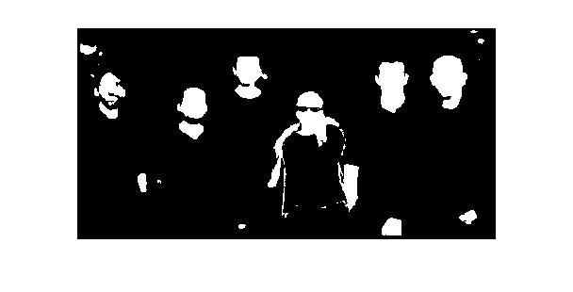
- HSV ∩ YCbCr
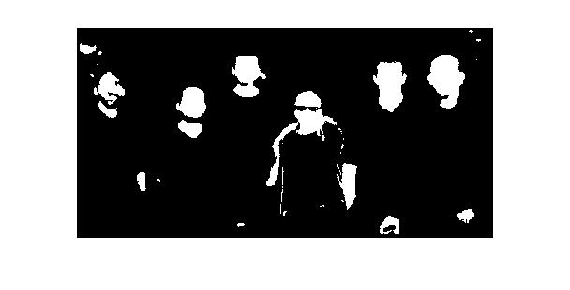
- RGB ∩ HSV ∩ YCbCr
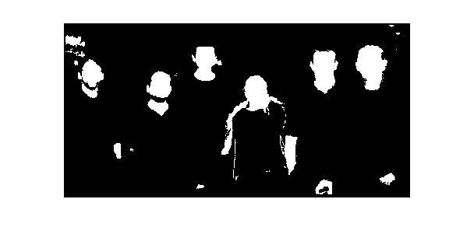

Experimental Results And Discussions

- RGB
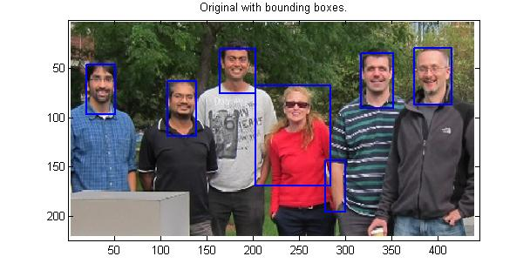

- HSV
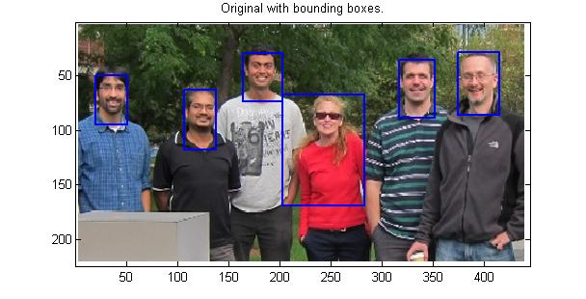

- YCbCr
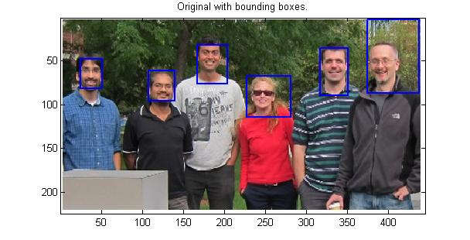
- RGB ∩ HSV
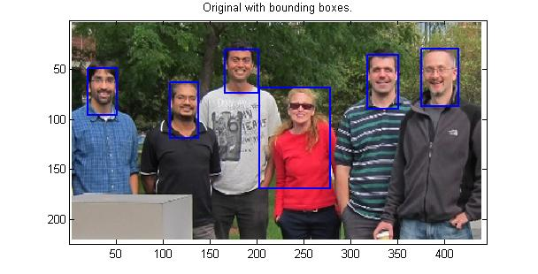
- RGB ∩ YCbCr

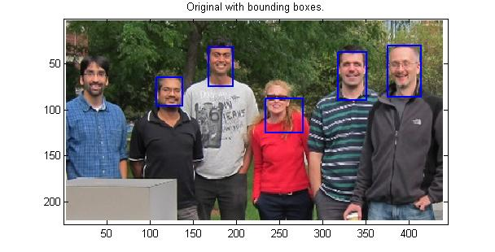

- HSV ∩ YCbCr
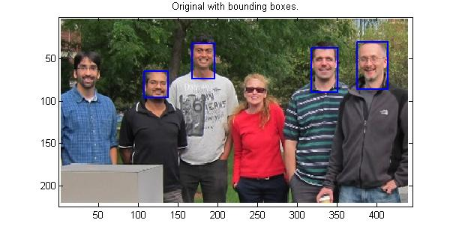

- RGB ∩ HSV ∩ YCbCr
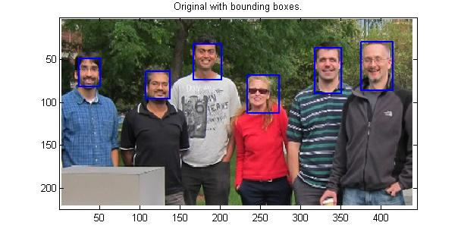
The proposed RGB-HSV-YCbCr skin color model for skin region segmentation was evaluated on a face detection system using a test data set of 30 images, containing a total of approx 150 unique faces. In order to build this test data set, the images were randomly selected from the Internet, each comprising of two or more near-frontal faces and of a large variety of descent (Asians, Caucasians, Middle-Eastern, Hispanic and African). The test images also consist of various indoor and outdoor scenes and of different lighting condition-daylight, fluorescent light, flash light (from cameras) or a combination of them. The face detection system was implemented using MATLAB 7.9.0.

To evaluate our experiments, we defined two performance metrics to gauge the success of our schemes. False Detection Count (FDC) is defined as the number of false detections over the total number of detections.
No. of false detections
FDC = -------------------------------------- × 100%
Total number of detections
Detection Success Count (DSC) is defined as the number of correctly detected faces over the actual number of faces in the image.
No. of correctly detected faces
DSC = ---------------------------------------- × 100%
Total number of faces
where the number of correctly detected faces is equivalent to the number of faces minus the number of false dismissals.
To evaluate the effectiveness of the RGB-HSV-YCbCr skin color model, the face detection system was tested with various combinations of color models, each represented by its own set of bounding rules.

Some More Results:

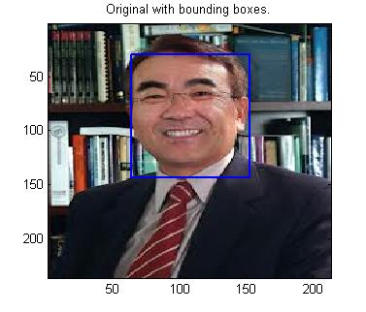
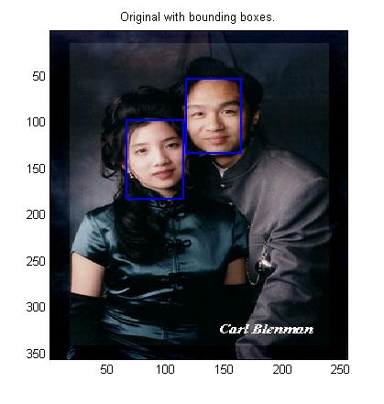
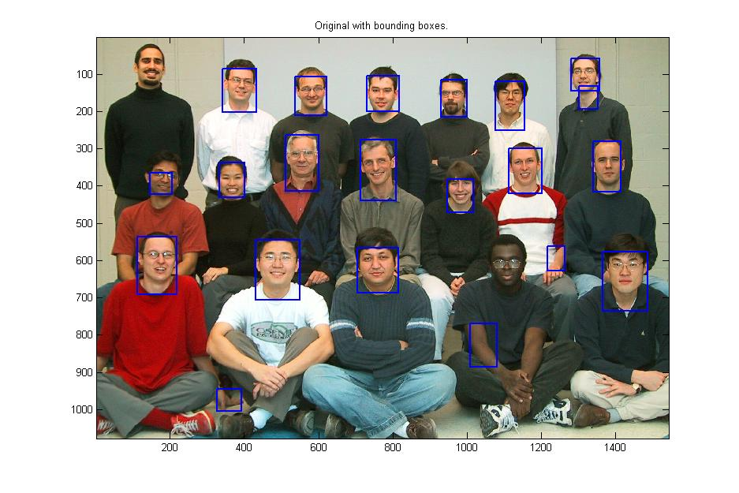
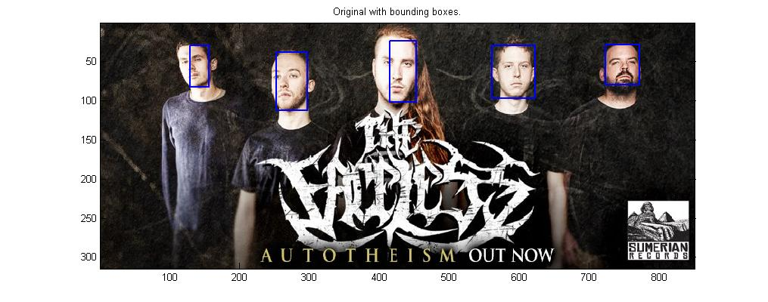
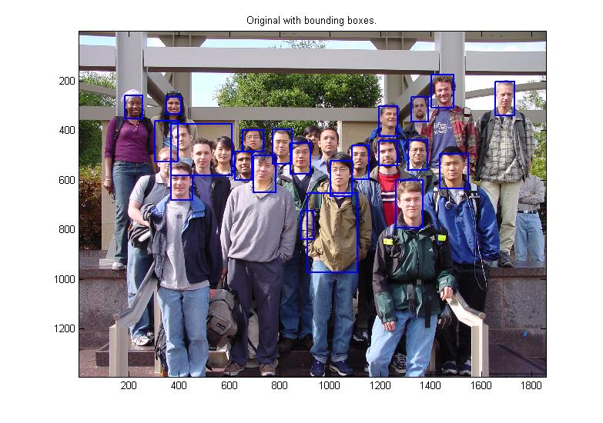
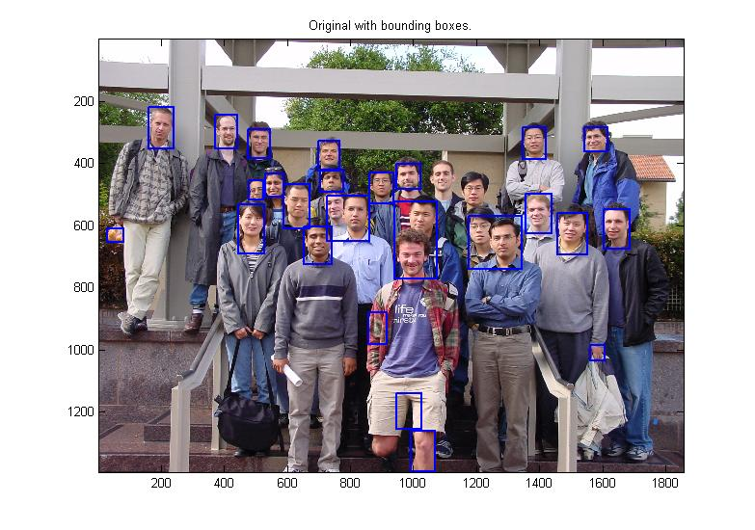
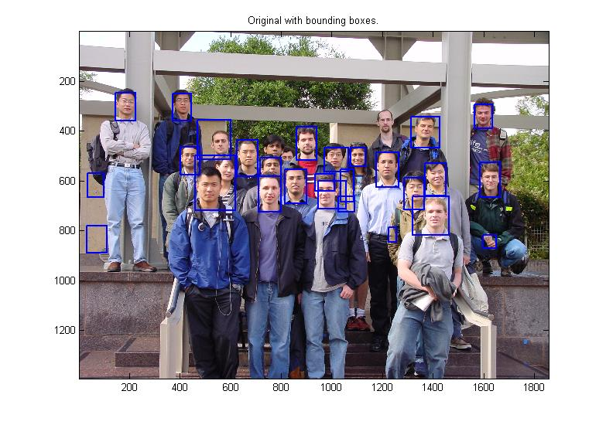

Conclusion
Even though there are many modern and accurate types of software today yet in this paper, we have presented a novel skin color model, RGB-HSV-YCbCr to detect human faces for students with minimal knowledge in image processing. The Skin region segmentation was performed using combination of RGB, HSV and YCbCr subspaces, which demonstrated evident discrimination between skin and non-skin regions. The experimental results showed that our new approach in modeling skin color was able to achieve a good detection success rate.
This project would serve as a stepping stone for future improvements and modifications. As it is simple to understand hence it will readily understood by students who then will be encouraged to make modifications and create a more sophisticated project.

Acknowledgment

At first we would like to express our profound gratitude to Dr. Kishore S. Prahallad ,
Assistant professor, International Institute of Information Technology, Hyderabad.
Next we must be thankful to our mentor Aabid Azeem.

References

- R.-L. Hsu, M. Abdel-Mottaleb, and A. K. Jain, "Face detection in
color images," IEEE Trans. PAMI, vol. 24, no. 5, pp. 696-707, 2002.
- S. L. Phung, A. Bouzerdoum, and D. Chai, "Adaptive skin
segmentation in color images," Proc. ICASSP'03, 2003.
- S. L. Phung, A. Bouzerdoum and D. Chai, “Skin segmentation
using color pixel classification: analysis and comparison,” IEEE
Transactions on Pattern Analysis and Machine Intelligence, 27(1)(2005) 148-154.
- V. Vezhnevets, V. Sazonov, and A. Andreeva, “A Survey on Pixelbased
Skin Color Detection Techniques,” Proc. Graphicon2003,
Moscow,Russia,September2003.
[5] R. Kjeldsen and J. Kender, “Finding Skin in Color Images,” Proc.
Int. Conf. AFGR’06, Killington, Vermont, pp. 312-317, 2006.
[6] S. Gundimada, L. Tao, and V. Asari, “Face Detection Technique
based on Intensity and Skin Color Distribution,” ICIP2004, pp.
1413-1416,2004.

